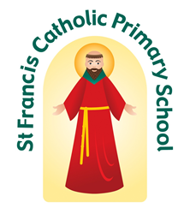
St Francis Catholic Primary School
Myers Lane, Bradford BD2 4ES
Tel. 01274 638520
Email: office@stfrancisbrad.co.uk
Website: www.stfrancis.bradford.sch.uk Twitter: @stfrancisbrad
Executive Headteacher: Mr D. Copley
Head of School: Mrs A. Haines
Together we are exploring our special gifts; Together we are growing towards God

Your Tuesday News 20th October 2020
‘TOGETHER WE ARE GROWING TOWARDS GOD’

Worship
On Monday, Ms Jennings led our other faith worship, Judaism.
The children learnt about the sacred celebration of Yom Kippur (Day of Atonement). In September or sometimes October, ten days after Rash Hashanah, Jewish people reflect on their regrets and mistakes over the year and pray to God for forgiveness. Then they start afresh and move forward. We discussed how this was similar to our Reconciliation Sacrament and Saying Sorry services. To help the children understand more Ms Jennings retold the story of’ Jonah and the Whale’, a reading that Jewish adults share with their children during the ten days of reflection to show how God, even when you make mistakes, will still always listen. After this the children, as a class discussed, some of their regrets and added them to a piece of paper, reflected on these and prayed to God. To move forward from these regrets the children screwed the paper up and put it away, for forgiveness has been asked for.

Continuing on from our other faith worship, the children will be learning more in-depth different aspects of the Jewish faith this week such as the Synagogue, Rosh Hashanah, Persecution of Faith and similarities between our faith and the Jewish faith through baptism. On Friday, all the children
will be learning about the sacred ‘Shabbat’ service that Jewish people take part in on Friday evening where we will be sharing some ‘Challah’ bread and learning about the sacredness of the Shabbat.

Sacramental Preparation
We are aware that we have children who had either finished their preparation for their next sacrament or were in the middle of their preparation just before lockdown occurred. We are currently liaising with Fr Anthony and the Diocese to put 'catch-up' plans in place to address this. We will have more information to share with you after the half term holidays. Please bear with us as we make our way through the guidance!

God Bless from Mr Copley and Mrs Haines
CLASS | % ATTENDANCE  w/b: 12.10.20. | %ATTENDANCE  this year to date
FS2 | 99.32 | 97.49
Year 1 | 99.65 | 98.15
Year 2 | 99.33 | 97.58
Year 3 | 97.33 | 98.31
Year 4 | 99.35 | 98.88
Year 5 | 99.21 | 97.68
Year 6 | 96.28 | 96.00
Average | 98.63% | 97.72%
TARGET | 97.00% | 97.00%
EVERY SCHOOL DAY COUNTS:
Our Attendance Target for this year is 97%

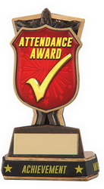
Year 1 are our attendance champions for last week. It was a very close call as most classes were above 99% last week. Well done everyone.

TOGETHER WE ARE EXPLORING OUR SPECIAL GIFTS

Our Merit Winner’s on Friday were: Luka Tsiklauri, Kaleb Parker, Tulisa Durkin, Kayl Walker and Scarlett Zabarowski. Well done everyone.
Mrs Haines’ Headteacher’s Award: Femi-Lee Whittingham for being an absolute pleasure to have at St Francis. Femi’s superstar character and enthusiasm for school life makes everyone smile.

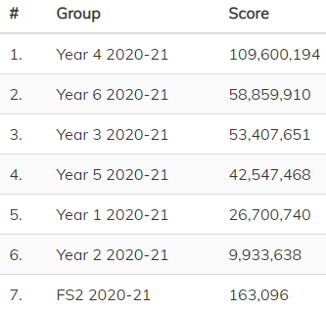
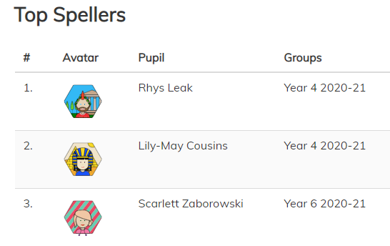
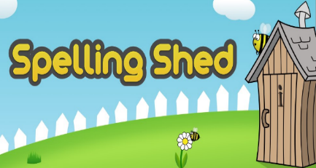

Performance Poetry
Our Performance Poetry programme is continuing this year with Years 1,2 and 3 performing their chosen poems this Thursday morning. As you are aware, unfortunately parents are not able to come into school at the moment. It is still our intention to ensure opportunities are built into our curriculum to increase our children's confidence in speaking. Consequently, the children will 'perform' their poems in the large hall for the rest of the school watching via video link. We hope this will give them a sense of an audience, even if the audience cannot actually be there in front of them.

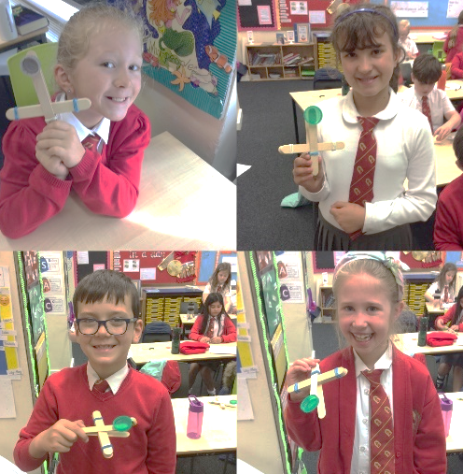
Year 4 Design Technology
Last week Y4 spent two afternoons focusing on their Design Technology project for this half term. On Thursday afternoon they used lollipop sticks, elastic bands and recycled bottle tops to make a model Roman catapult. On Friday afternoon the children evaluated their work, wrote up their method and even got a chance to fire some balls of paper across the classroom!

FOUNDATION STAGE
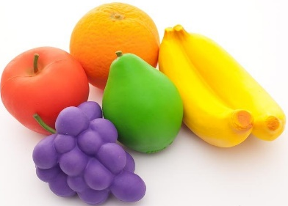
Resources needed!
Foundation stage are really running short on good quality dinosaurs, baby dolls (that do not cry or make noises!) and play food. If you have any of these going spare, we would be extremely grateful of them. They can either be dropped in at the office or handed over directly to Foundation Stage staff. Many thanks.

FS1/FS2 Parent Consultations
Consultations are taking place over the phone over Monday, Tuesday and Wednesday this week. A separate letter has gone out with dates, times and how to make an appointment. If you have missed it, it is available on our website here:
https://www.stfrancis.bradford.sch.uk/learning/foundation-stage

Covid 19 Update
As the weather is becoming colder and due to the importance of all areas around school being well ventilated, including classrooms, please can you ensure that your children are wearing appropriate layers. Certainly after half term, children will need a vest or a t-shirt (perhaps even both) underneath their uniform in order to keep them warm whilst inside school.

Please continue to social distance at drop off and pick up and ensure you arrive at your allocated time and leave the school premises as quickly as possible. Thank you as always for your continued support during these difficult times.

If you are worried or concerned about the wellbeing of any of our pupils, please ask to speak to
Mrs Haines, Miss Burgess, Miss Martin or Mrs Laptew

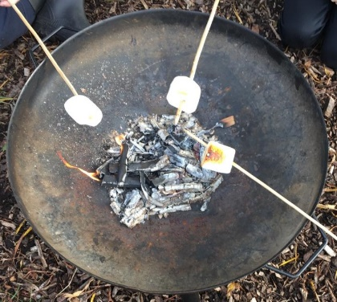
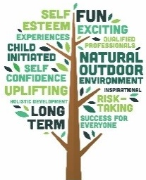
Forest School
Y5 have been thoroughly enjoying their Forest School adventures with Go Wild Outdoors. Next half term it will be Year 3's turn. Please ensure that children come to school dressed ready for Forest school every Friday and bring a change of footwear with them.

Can you guess what Year 5 were doing last week?
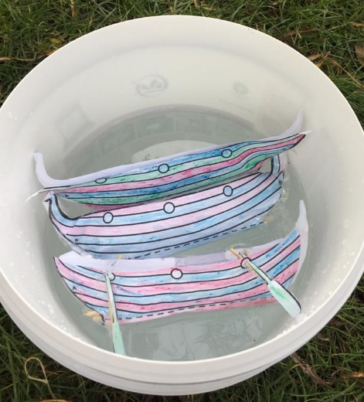
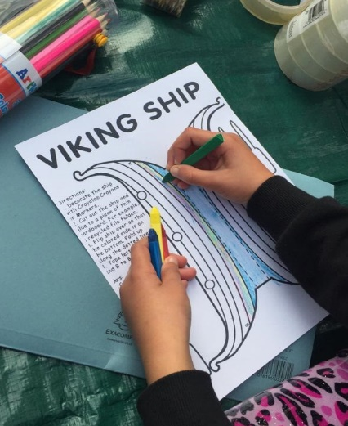
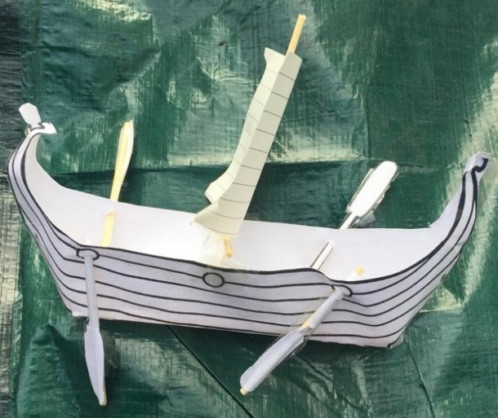

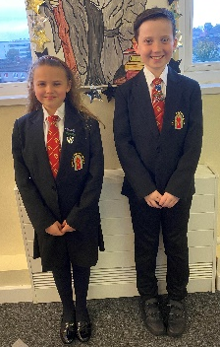
Introducing our Head Boy and Head Girl
Congratulations to Tobias and Gracie-Mae on being elected as St Francis' Head Boy and Head Girl for 2020-2021.

We are thrilled that you will be representing our school and we are really looking forward to your leadership. Good luck

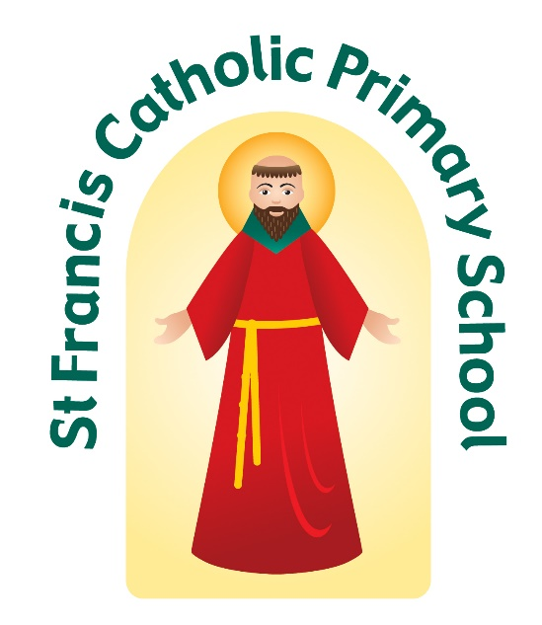
We would like to thank all our families for your co-operation and support during this difficult first half term which has helped us to keep all our children and families safe in school. We wish you all a safe and restful half term.

