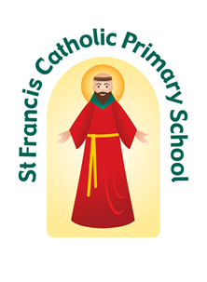
St Francis Catholic Primary School
Myers Lane, Bradford BD2 4ES
Tel/fax: 01274 638520
Executive Headteacher: Mr D. Copley
Head of School: Mrs A. Haines
Email: office@stfrancisbrad.co.uk
Website: www.stfrancis.bradford.sch.uk @stfrancisbrad

Together we are exploring our special gifts; Together we are growing towards God

Your Tuesday News 3rd December 2019
‘TOGETHER WE ARE GROWING TOWARDS GOD’
Advent
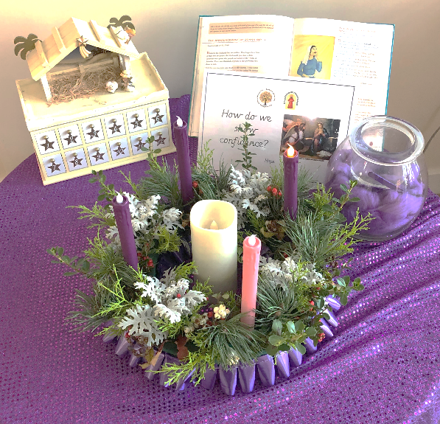
In church on Sunday, we celebrated the first Sunday of Advent. Yesterday in worship, we lit our first purple candle on the Advent wreath and discussed what Advent is all about. Advent is a time of preparation - preparing our hearts for the coming of Jesus. We talked about how important it is to 'stay awake' - not literally of course, but to make sure we are alert and living in the right way as we wait for Jesus.

Advent Prayers
Every morning throughout Advent, we will be holding very short prayer sessions together in the small hall at 8:25am. These are very relaxed and peaceful and aim to help us focus on the true meaning of Christmas. We are very lucky that our Mini Vinnies will be leading some of these. All parents, carers and families are very welcome to join us.

Saying Sorry and Penitential Service
Yesterday, our FS2 and KS1 children took part in a lovely saying sorry service with Fr Anthony. Afterwards, KS2 children shared in a Penitential Service and then prepared their hearts for Jesus by going to confession with Fr Anthony.

Gianna Project
Once again this year, we will be supporting the Gianna Project as our chosen charity. The Gianna Project was established in 2011 and since this time has supported more than 550 families with items from their baby bank and much needed emotional and practical support. We are collecting any kind of baby items, such as nappies, wipes, clothes, bottles etc. Please simply send any items in with your child or drop them off at the school office. Thank you in advance for your support.

Advent Mass
Our Advent Mass takes place this year on Wednesday 18th December at 10:30am. This is always a very special Mass and we invite all parents/carers and families to come along and share in this with us.

KS1 Liturgy
The children in Y1 and Y2 are already practising very hard for their Nativity, which is called 'Shine Star Shine' . It will take place on Friday, 13th December at 9am in the school hall. We look forward to seeing you there. God Bless from Mr Copley and Mrs Haines
CLASS | % ATTENDANCE  w/b 25.11.19. | %ATTENDANCE  this year to date
FS2 | 96.00 | 97.20
Year 1 | 97.67 | 96.61
Year 2 | 97.42 | 97.78
Year 3 | 96.45 | 97.27
Year 4 | 97.4 | 96.90
Year 5 | 98.06 | 97.80
Year 6 | 92.26 | 96.22
Average | 96.14% | 97.11%
TARGET | 97.00% | 97.00%
EVERY SCHOOL DAY COUNTS:
Our Attendance Target for this year is 97%

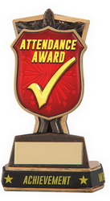
Well done to Year 5 who achieved over 98% attendance last week. This is the time of year when bugs are ever present all around us and it has a big impact on our attendance figures.

TOGETHER WE ARE EXPLORING OUR SPECIAL GIFTS
Well done to our Merit Winners last week: Leo Raistrick, Nylah Doherty, Bella Clapham, Amelia Whitehead, Olivia Wilson, Poppy Grant and Samuel Hawker. Well done everyone.
Mr Copley and Mrs Haines’ Headteacher’s Award was presented to Jake Boyle for a real mature attitude to school life and real determination to improve his work.

Big Cat Reading Award was presented to Blake and Lincoln Stanley for their exceptional commitment to reading at home.

Our Mathstronaut last week was Scarlett Zaborowski. Well done to all our award winners.
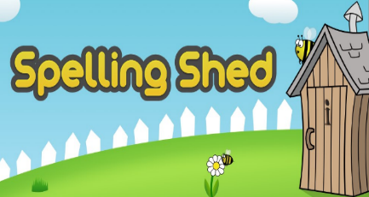
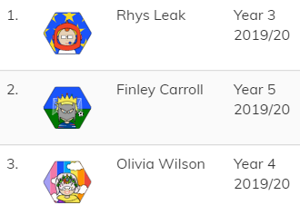
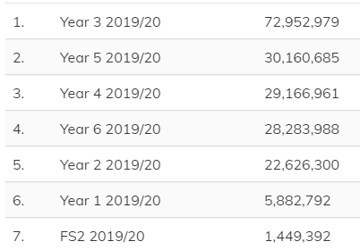

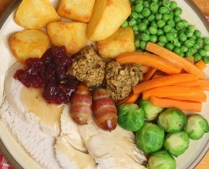
Christmas Dinner
Our Christmas Dinner this year is on Monday 9th December. Children who do not wish to have a Christmas Dinner may bring something festive in their lunchbox. Chilli will be served on Wednesday next week instead of the Monday. Please note children will not be dressing up on this day. See below regarding Festive Friday. Please fill the slip below if your child would like a Christmas dinner and return to school by Friday.
------------------------------------------------------------------------------------------------------------------

Name of Child(ren): ……………………………………………………………………………… Classes: ……………………………………….
My child (ren) would like a Christmas dinner on Monday 9th December.

Signed: ……………………………………………………………………………………………………. Date: ………………………………………….
Festive Friday
On the last day of term, Friday 20th December, for the cost of £1, all the children are invited to come to school dressed in something festive. All proceeds will go to the PFA. Thank you.

EYFS News
FS advent Workshops and Worship
These will take place on Wednesday 11th, Thursday 12th and Friday 13th December. All parents/carers and families are welcome to come along and join the children at this special time.

FS Advent Celebration
On 18th December we invite FS1 morning group back for an Advent celebration at 1.20pm. Further details will be coming home from Foundation Stage staff.
Thank you to everyone who has engaged with the app and completed the activities. Please continue to do so.

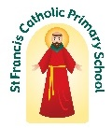
PFA News
Movie Night – Please find below a booking slip for Movie Night on Thursday 12th December at 3.15 pm. Children from FS1 are welcome but a parent will need to accompany their child. The tickets cost £5 each and includes popcorn, hot dog and a drink.
------------------------------------------------------------------------------------------------------------------
Name of Child(ren): ……………………………………………………………………………… Class(es): ……………………………………….
I require …….. tickets for the PFA Movie Night and enclose £ ……… payment
I give consent for my child(ren) to attend the PFA Movie Night

Signed: …………………………………………………………………………………………………. Date: ………………………………………………

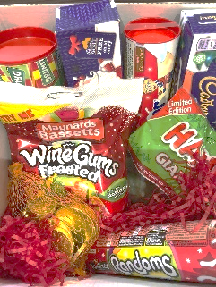
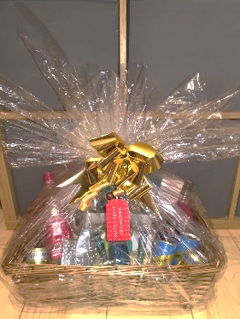
Christmas Raffles – We have a Gin Hamper and a children’s Chocolate Sweet Hamper to raffle. Tickets cost £1 a strip and are available to buy from a PFA member in the school playground. If you are unable to buy a ticket and would like one please fill in the slip below and we will ensure that you receive your tickets.

------------------------------------------------------------------------------------------------------------------

Name of Eldest Child: ……………………………………………………………………………… Class: ……………………………………….
I would like to buy …….. ticket(s) for the Christmas Raffle at £1 per ticket. I enclose £ ……..
Signed: ……………………………………………………………………………………………………. Date: ………………………………………….

Increase in school meals prices
From 1st January the cost of a school meal will increase to £1.90. For children in FS1, who attend for 30 hours and take a meal, this will increase to £1.70.

The Macmillan Coffee Morning which we held in September raised a whopping £221.58. Thank you to all who attended and supported the event.

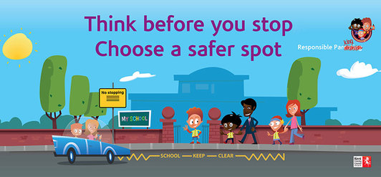
Last week we had a message from a very upset elderly gentleman. One of our parents had parked on his lovingly tendered grass verge and had driven off at speed, churning up his grass. We regularly have neighbours ringing in about the unthoughtful and dangerous parking of our parents outside school. Please please think about where you are parking and if it is safe for children crossing the road. THINK BEFORE YOU PARK!

After School Club
This week in after School Club, the children will be putting up the school Christmas tree and making decorations with tea bags and wax. The mind boggles!! There will be lots of winter activities to look forward to between now and Chrismta.
PLEASE NOTE: After School Club will NOT be open on Friday 20th December

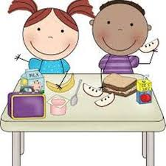
Lunchtime Supervisor Vacancy
We currently have a vacancy in school for a lunchtime supervisor to work every day from 12.00 – 1.00 pm. If you are interested, or know anyone who might be please let us know. Application forms are available from the school office. If you would like any further information please speak to Mrs Haines or ask at the office.

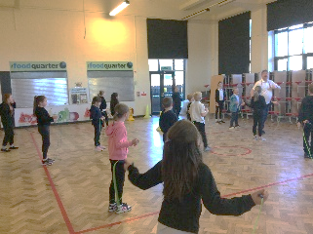
Skipping School
What a fantastic day everyone had on Friday! Each year group from FS2 to Year 6 took part in a skipping workshop where they learnt lots of new skills and games. Children are so excited to be getting the skipping ropes out at break and lunch.

On Friday, year 5 were very fortunate to be invited to attend a classical musical concert led by Leeds Lieder. The children enthusiastically listened to a range of songs sung by operatic singers. At the end, all the schools who attended were asked to sing the verse they created. Year 5 sang theirs beautifully and confidently. Well done!

If you are worried or concerned about the wellbeing of any of our pupils, please ask to speak to Mr Copley,
Mrs Haines, Miss Burgess or Mrs Laptew

